Chapter 10 Reading Guide: From DNA to Protein
Concept 10.1: Genetics Show That Genes Code for Proteins
- “One gene-one polypeptide” –

- Molecular biology

- Gene expression
  - Transcription
    - DNA template
    - mRNA
  - translation
    - rRNA
    - tRNA

Concept 10.2: DNA Expression Begins with Its Transcription to RNA
- components of transcription
  - DNA template
  - Nucleoside triphosphates (substrates)
  - RNA polymerase

- Transcription occurs in three steps
  - Initiation
    - RNA polymerase

    - Promoter

  - Elongation
    - RNA polymerase
      - Unwinds
      - Reads
      - Adds
    - mRNA is antiparallel to DNA template
    - mRNA is complementary to DNA template
  - termination

- pre-mRNA is modified
  - introns are removed
    - introns
    - exons
    - spliceosome
  - ends are chemically modified
    - 5’ cap
    - Poly-A tail

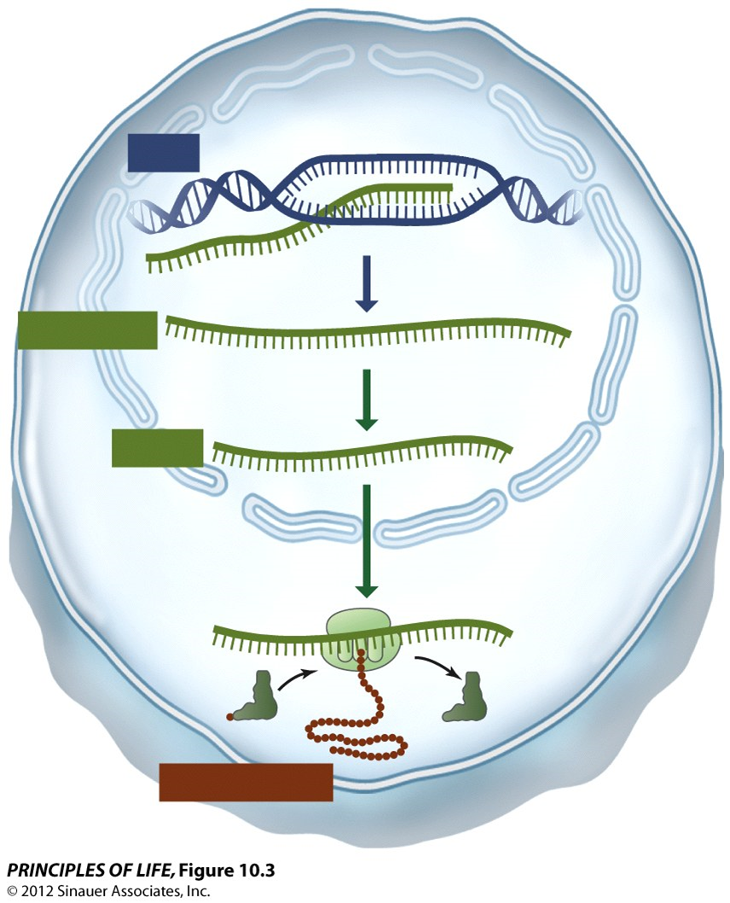
Concept 10.3: The Genetic Code in RNA Is Translated into the Amino Acid Sequences of Proteins
- Codons
  - 20 different aa
  - Start codon
  - Stop codon

- Characteristics of the genetic code
  - Redundant
  - Universal

- Mutations and the genetic code
  - Point
  - Silent
  - Missense
  - Nonsense
  - Frame-shift

Concept 10.4: Translation of the Genetic Code Is Mediated by tRNA and Ribosomes
- tRNAs
  - bind to amino acids at the ___________________site
  - bind to mRNA via the ______________________
  - aa specific

- ribosomes
  - structure
    - large subunit
      - A site
      - P site
      - E site
    - Small subunit

- Translation takes place in three steps
  - Initiation
    - Initiation complex
    - Start codon
  - Elongation
    - First tRNA moves
    - Second tRNA binds
    - Peptide bond forms between two aa
    - First tRNA is released
  - Termination
    - Stop codon
    - Protein release factor

Concept 10.5: Proteins Are Modified after Translation
- Signal sequence
- Modifications
  - Proteolysis
  - Glycosylation
  - phosphorylation

